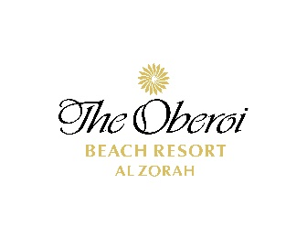
Water Sports

Activity | 15 Minutes |  | 30 Minutes | 45 Minutes | 60 Minutes | Age Policy
Jet Ski |  | 210/- AED | 370/- AED | 525/- AED | 630/- AED | 18 yrs min
Jet Ski Tour |  | - | - | 630/- AED | 735/- AED | 18 yrs min
Donut Ride  ( 2 to 4 pax ) |  | 210/- AED | - | - | - | 7 yrs min
Single Donut Ride |  | 315/- AED | - | - | -
Group Slide Ride  (2 to 3 pax ) |  | 210/- AED | - | - | - | 10 yrs min
Group Donut Tour  (2 to 4 pax ) |  | - | 420/-AED
Single Slide Ride |  | 315/- AED | - | - | - | 7 yrs min
Banana Boat Ride  (2-6 pax ) |  | 210/- AED | - | - | - | 7 yrs min
Pedal Boat  (2-4 pax ) |  | - | 265/- AED | 315/- AED | 420/- AED | 18 years
Kayak Ride  Per Person |  | - | 160/- AED | 210/- AED | 265/- AED | 18 years
Wake Board  (Instructor Min 3 sessions to be booked ) |  | 315/- AED | - | - | - | 18 years
Knee Board  (Instructor Min 3 sessions to be booked ) |  | 315/- AED |  |  |  | 18 years
Water Ski  (Instructor Min 3 sessions to be booked ) |  | 315/- AED | - | - | -
Stand up Paddle |  | - | 160/- AED | 210/- AED | 265/- AED

Term and Conditions
- Prior reservation is required for all the activities.
- Charges will be posted to the room.
- Prices are in AED inclusive of 5% VAT.
- Mandatory disclaimer form to be filled as provided by Al Hoot Water Sports.

