TIMELESS MEMORY – RECAP
- SUN BEACH
Details: Provide exceptional personalized service to guests while relaxing along the beach
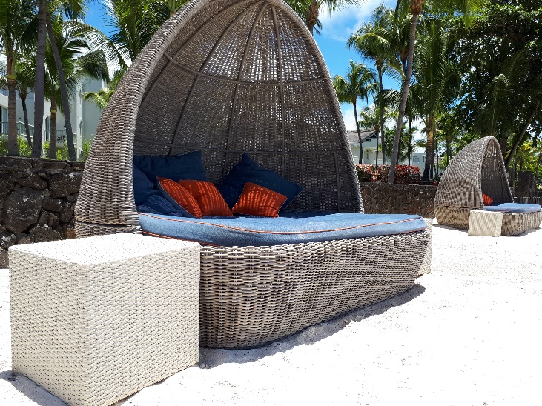
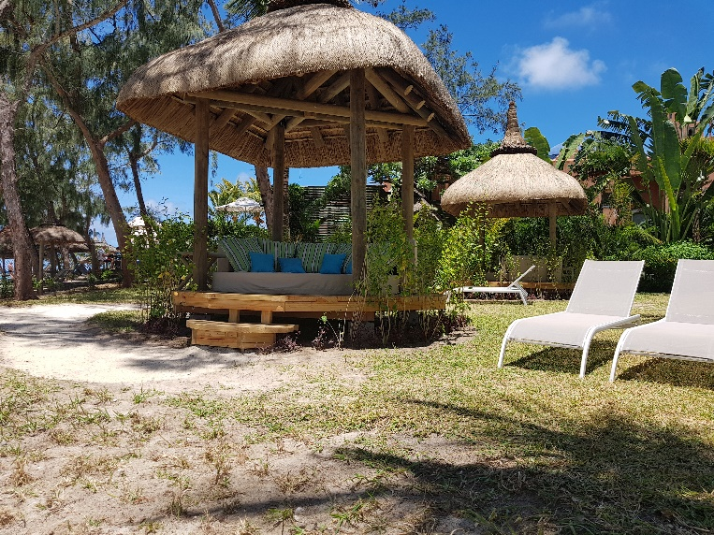

How:
- 20 Cocoon Beds
- 2 day beds
- Beach menu
- Butler service
Add-on:
- Foot Ritual of 15 mins (Day Beds only)
- Access to Jacuzzi at the Spa (Day beds only)
- WIFI
- Magazines
- Reserved sunbeds (Day Beds only)
Follow ups:
- Delivery of Cocoons beds pending
- To lower the fence to easily access the beach
- Finalize gate along the fence
- More sand to be spread around the day beds
- Tables to be placed next to the cocoon beds
- Tray jacks status
Price:
Cocoon Beds: Rs.1000 per day (09.00hrs – 18.00hrs)
Day Beds: Rs.1500 per day (09.00hrs – 18.00hrs)

- SUNRISE & SUNSET

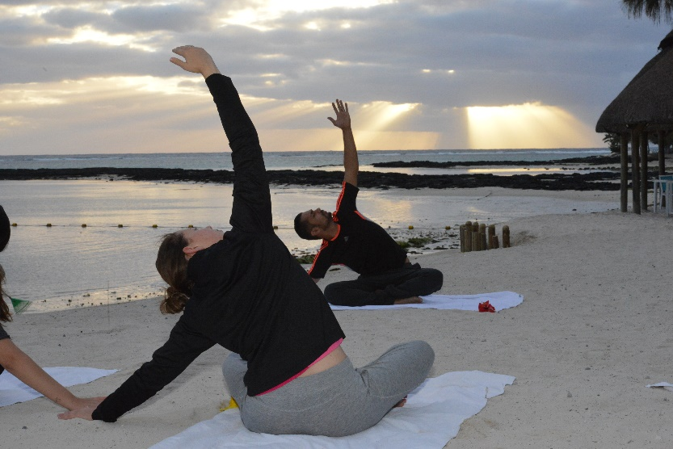
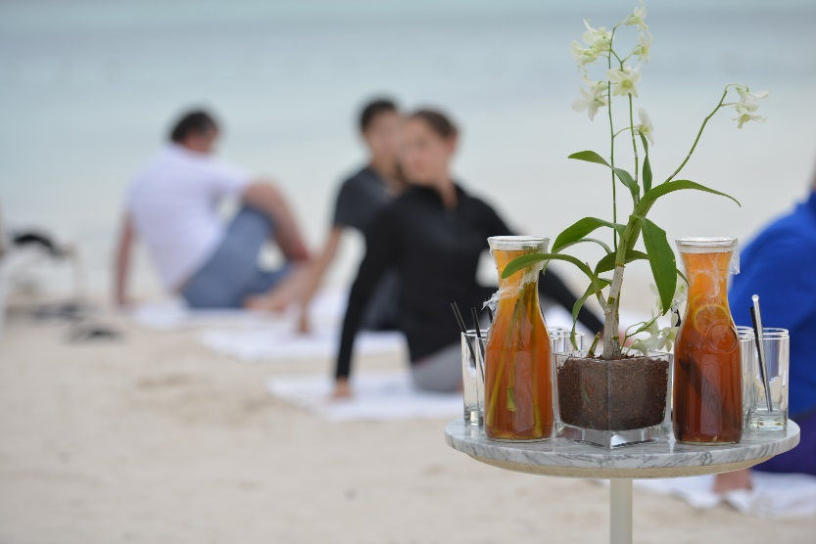
SunRise: Harmonizing your mind and body and embrace the light side of life…

How:
- Practicing Yoga at sunrise
Add-Ons:
- Detox drinks
- Fruit brochette
- Cold towels
Status: Complete and in practice

SunSet: Enjoying a toes in sand experience with cocktails in a tropical atmosphere
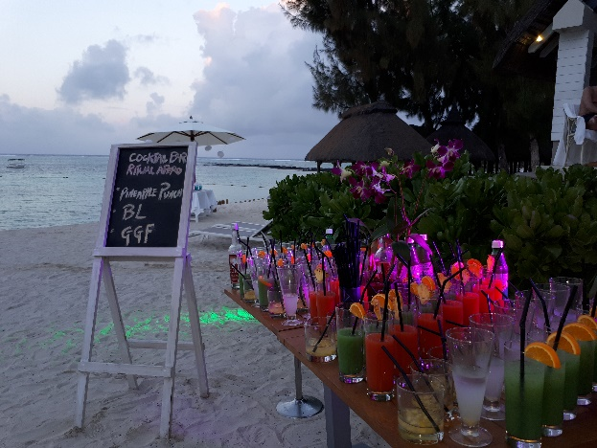
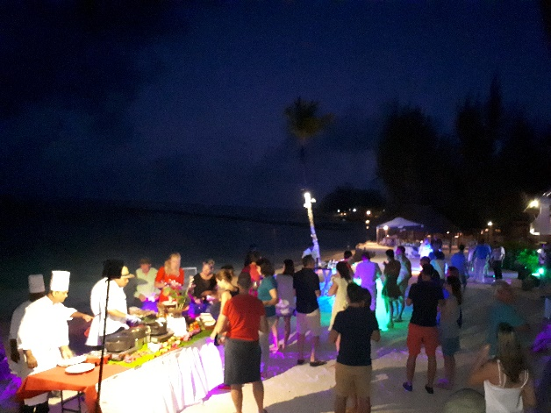

How:
- Sunset Rituals every Tuesday
- Mixologist
- Hot Snacks
- Bonfire on the beach
- Lounge Music

- SUN LUXURY MOMENTS
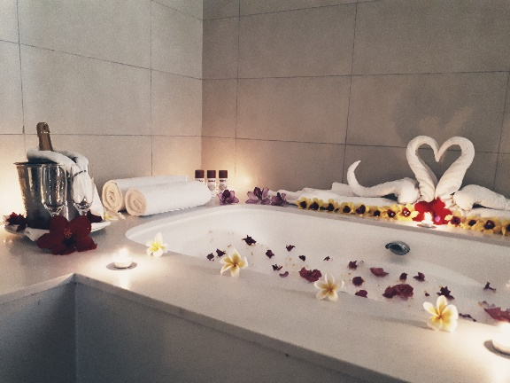
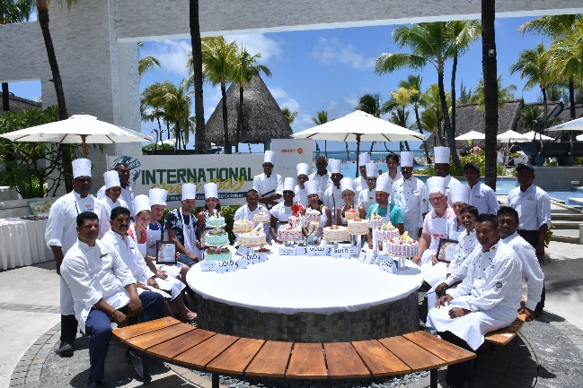
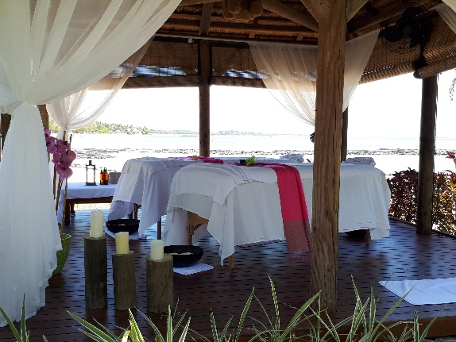
Details: always something unexpected. Each moment is tailored to our hotels’ signature style.

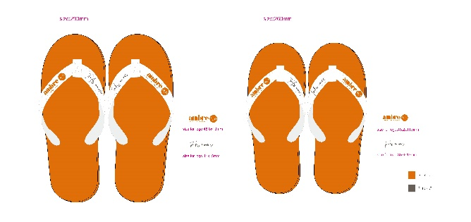
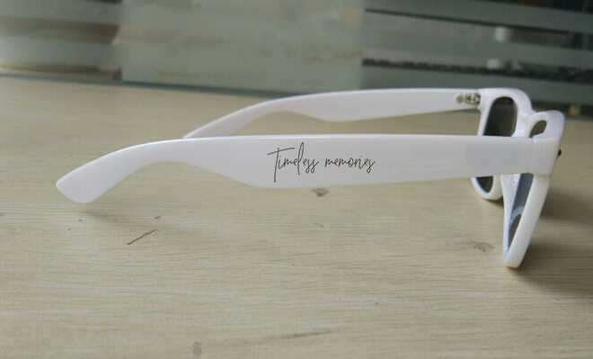
How:
- Holiday Chef (completed and in practice)
- Romantic set up in bedroom (completed and in practice)
- Couple massage Signature (completed and in practice)
- Giveaways on arrival & departure
Follow ups:
- Orders for gifts already placed. Delivery expected mid-November

- SUN MIXOLOGY
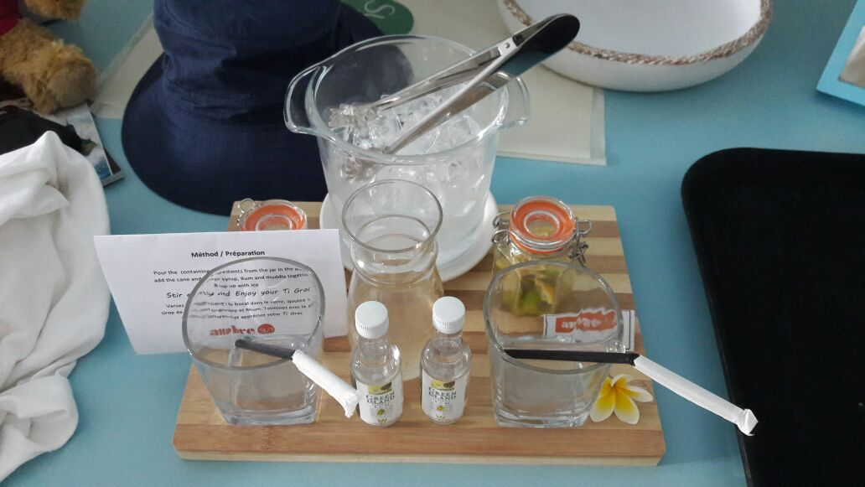
Details: Enjoy the art of cocktail making
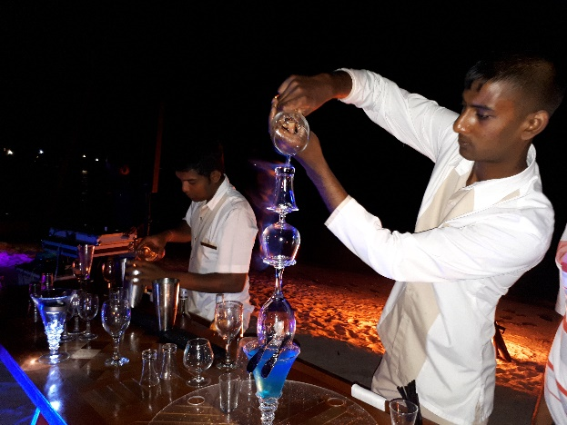

How:
- Cocktail making show during the Sunset Rituals every Tuesdays
- Make your own Cocktail – TiGrog

- SUN GOLF
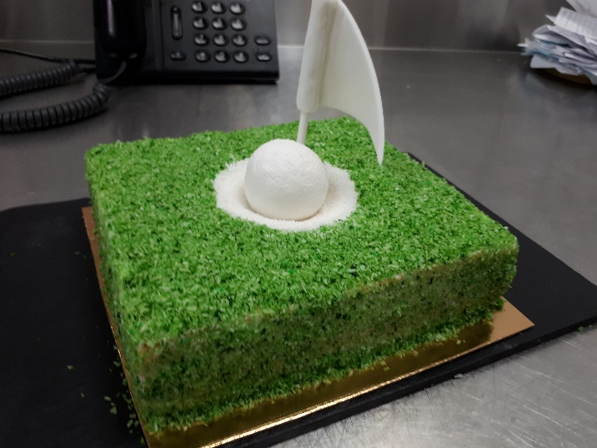
Details: Enhancing the stay of the golfing guests

- Cake for golfers
- Golfers massage
- Golf Cocktail

- SUN MEMORY LAB
Details: Every holiday has a story. We’ll make your timeless memories TANGIBLE.
- Outsourcing through Oomar Moideen
Follow up:
- Quotes for the lab received.

